**Evaluation of the Enhancing Cyber-Incident Management Process Using**

**Feature Models**

**Case Study -1: e-commerce domain**

Amman, Jordan

2023

**Case Study Evaluation Experiment**

**Participants:** Incident Response Team of e-commerce Company

IRT- Member-ID ----------------------------

1. **Objective**

The main objective of this case study is to investigate the applicability of the **Enhancing Cyber-Incident Management Process Using Feature Models** (FBCIMP) in real-world incident attacks that typically involve the shopping cart of an e-commerce website. They refer to security breaches or issues that affect the functionality, integrity, or privacy of the online shopping cart system.

1. **Experiment**

Based on the presentation section, the explanation of the proposed process, and the case study procedure, please resolve the cyber-incidents presented in Table 1 using both the cyber-incident management process and the FBCIMP.

Table 1: The cyber-incidents involved in the e-commerce website

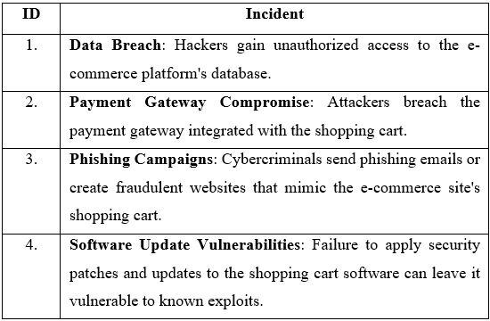

**Thank you for your collaboration and commitment to our shared case study**